Jefferson Bui

CMPSC 221

2020/02/25

Assignment 2

**Part 1:**

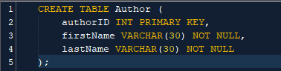

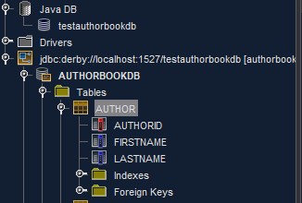

Wrote SQL code to create Author table in dummy database testauthorbookdb.

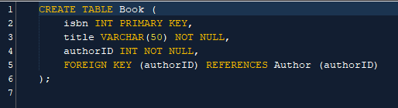

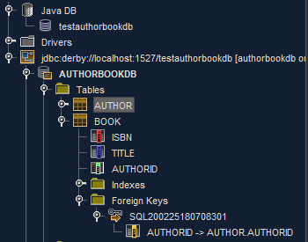

Wrote SQL code to create Book table in dummy database testauthorbookdb.

**Part 2:**

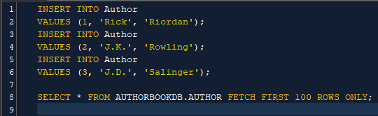

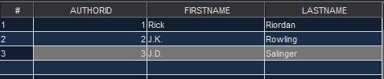

Inserted 3 different authors into Author table.

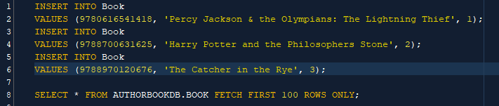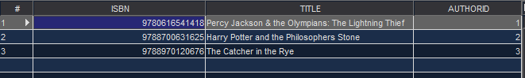

Inserted 3 books into Book table related to those Authors.

**Part 3:**

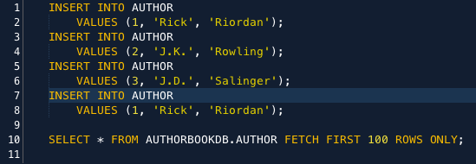



Added existing author into data base and returned primary key violation.

**Part 4:**

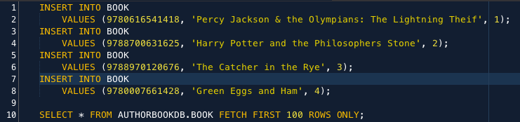



Added new book in Book table without an existing author in Author table and returned foreign key violation.

**Part 5:**



Gave meaningful names to SQL files and placed them under db.migrations package.

**Part 6:**

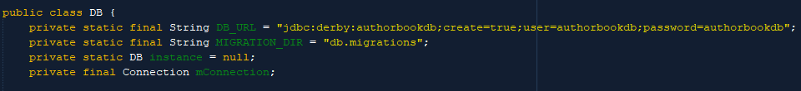

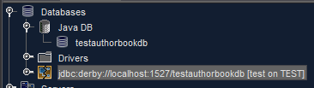

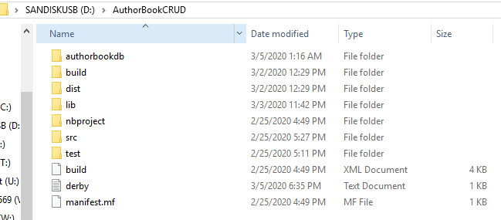

Named database as authorbookdb. Database is not in Java DB because flyway instead creates the database in the project file.

**Part 7:**

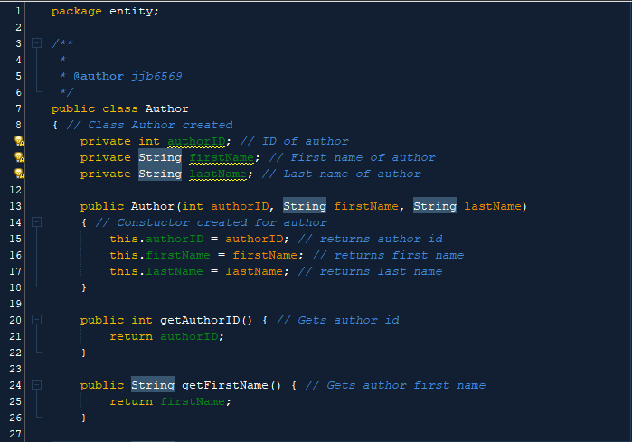

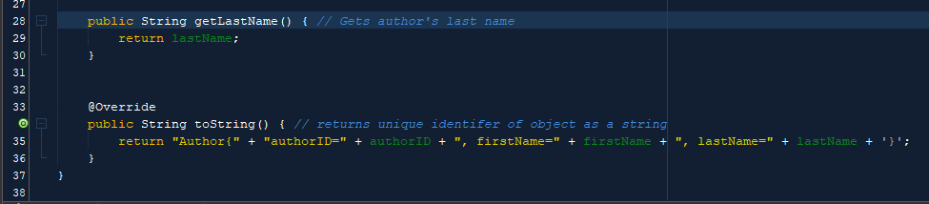

Modified class in entity for Author.java.

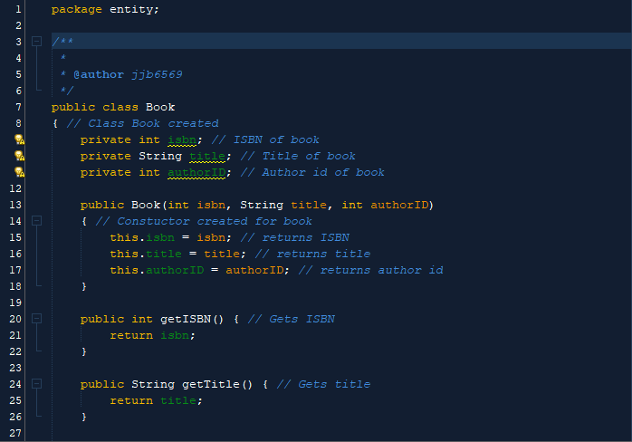

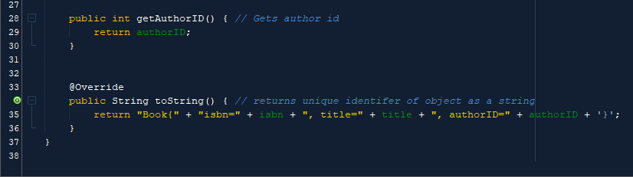

Modified class in entity for Book.java.

**Part 8:**

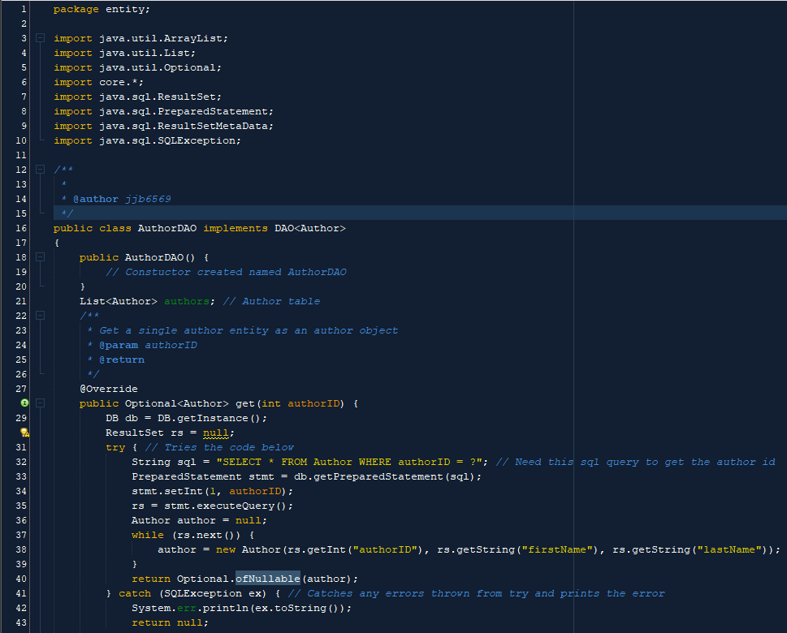

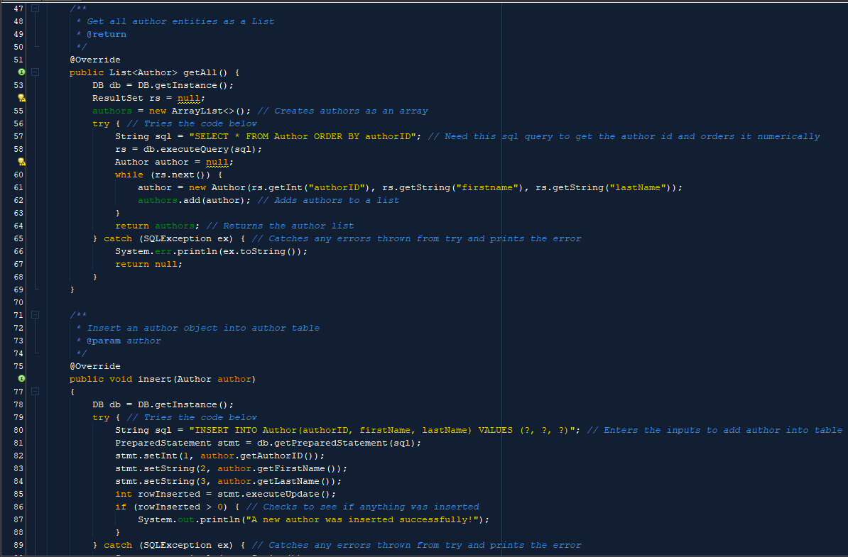

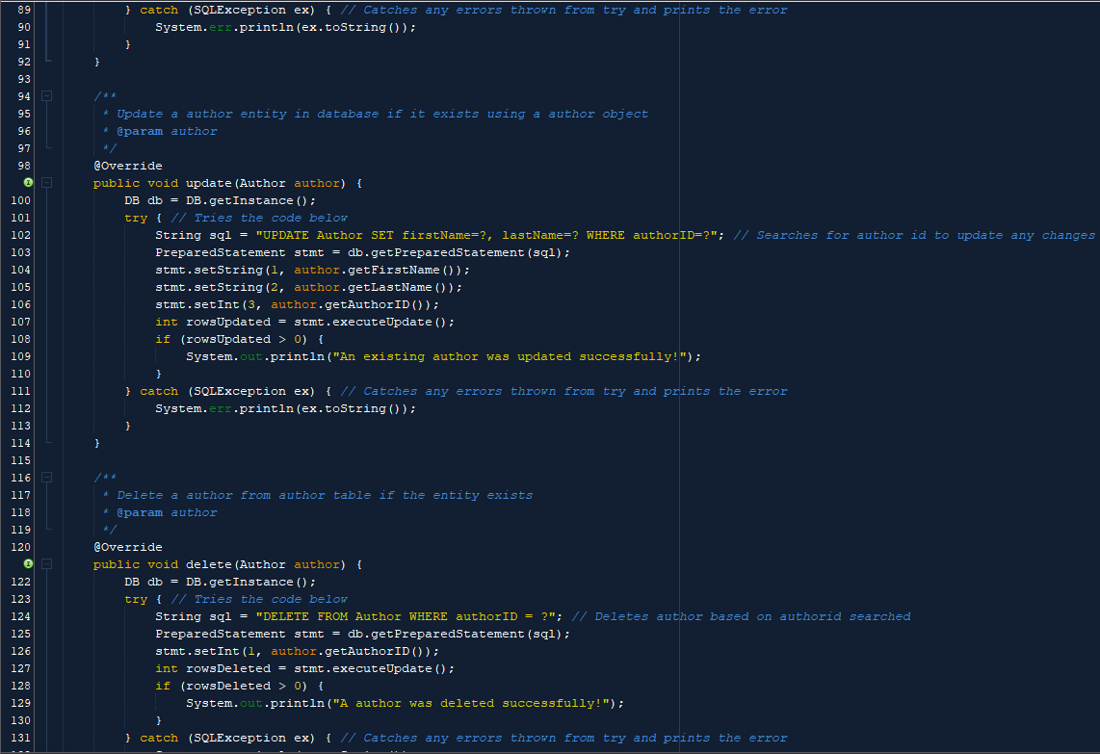

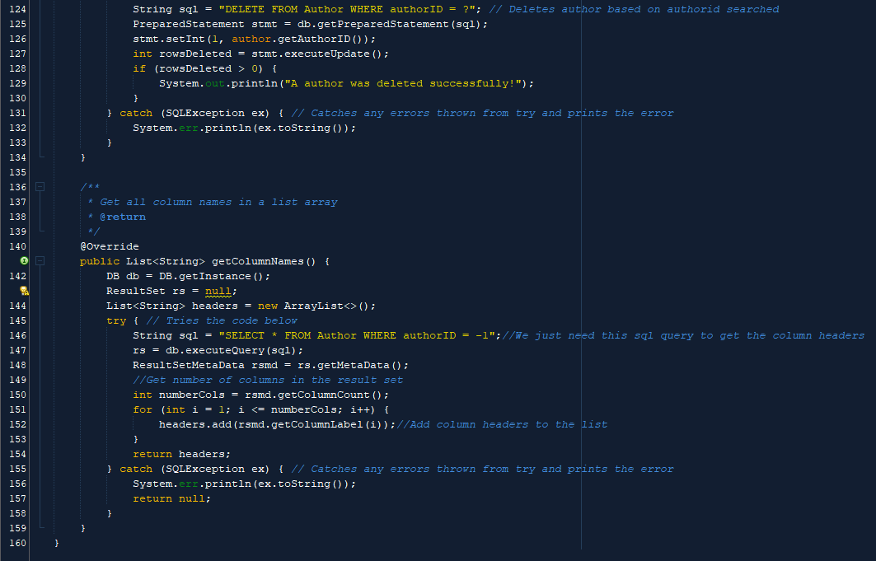

Modified entityDAO class for Author.

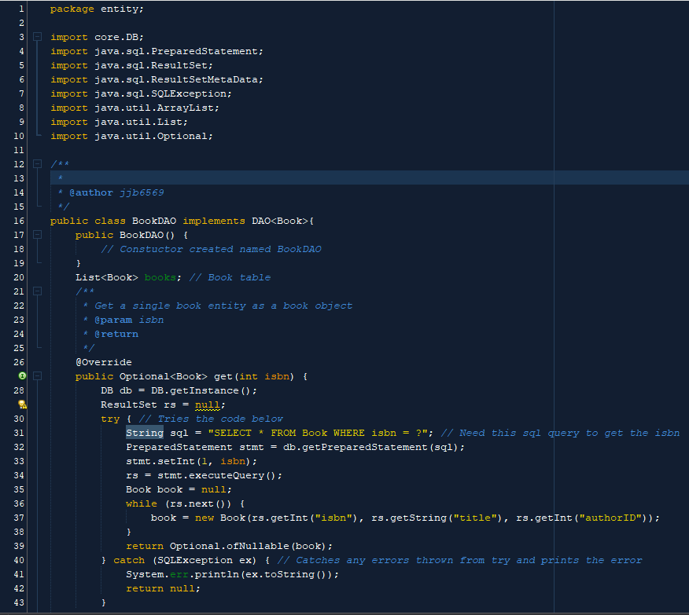

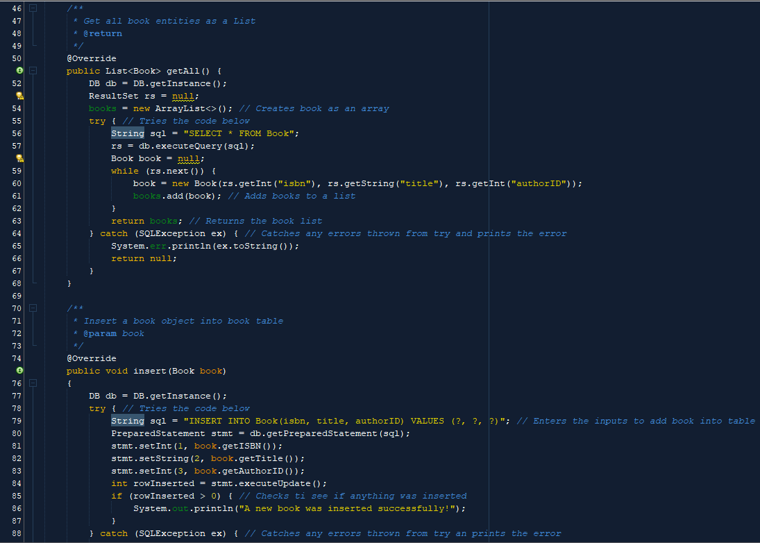

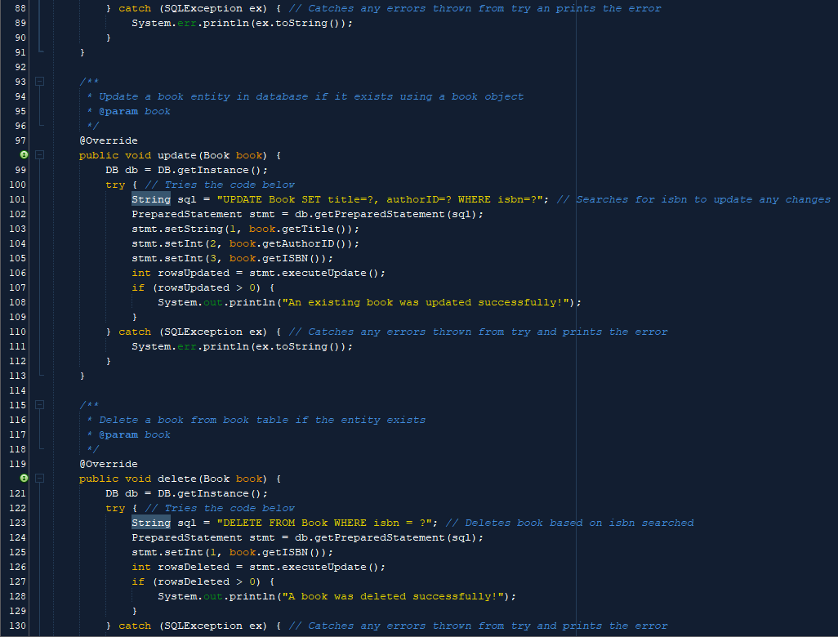

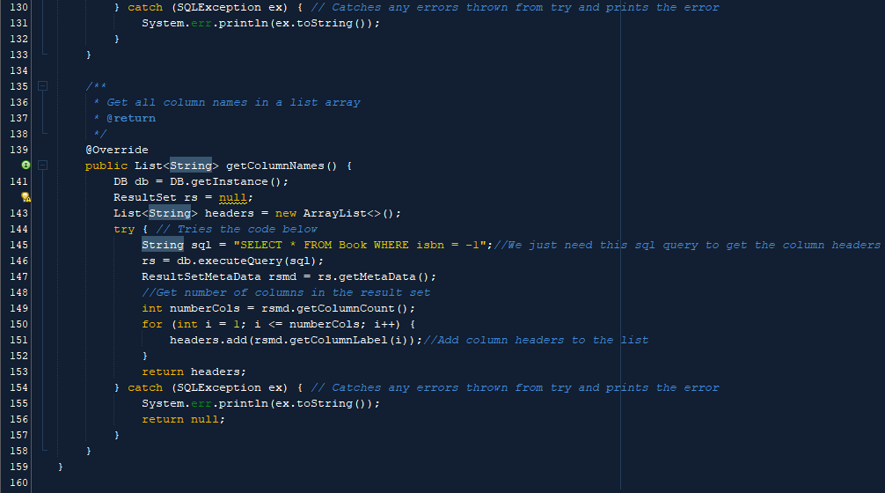

Modified entityDAO class for Book.

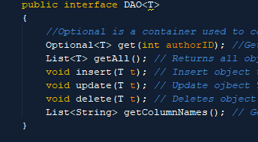

Only change done to DAO class was the variable name from id to authorID.

**Part 9:**

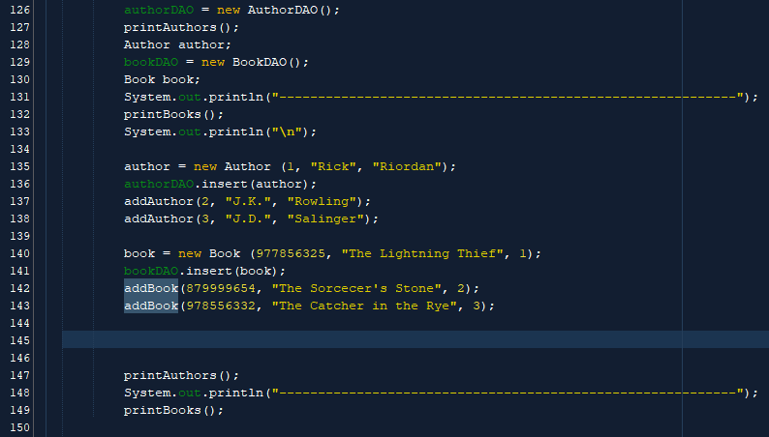

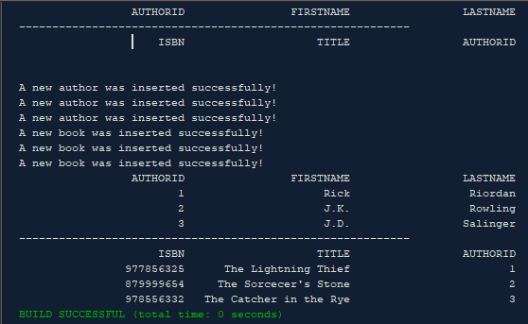

Added 3 authors and books into the database and ran code.

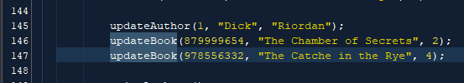

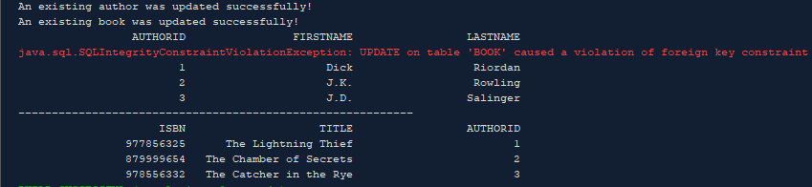

Updated one author’s first name and book’s title. Also updated a book to a non-existing author in author database foreign key violation.

**Part 10:**

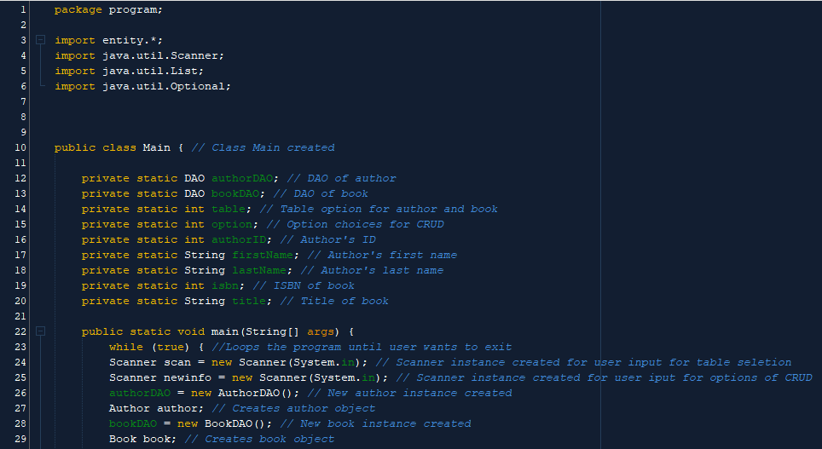

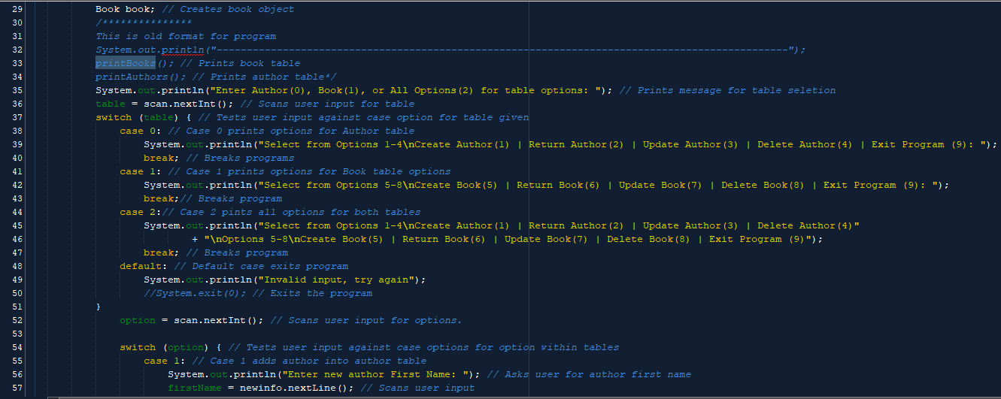

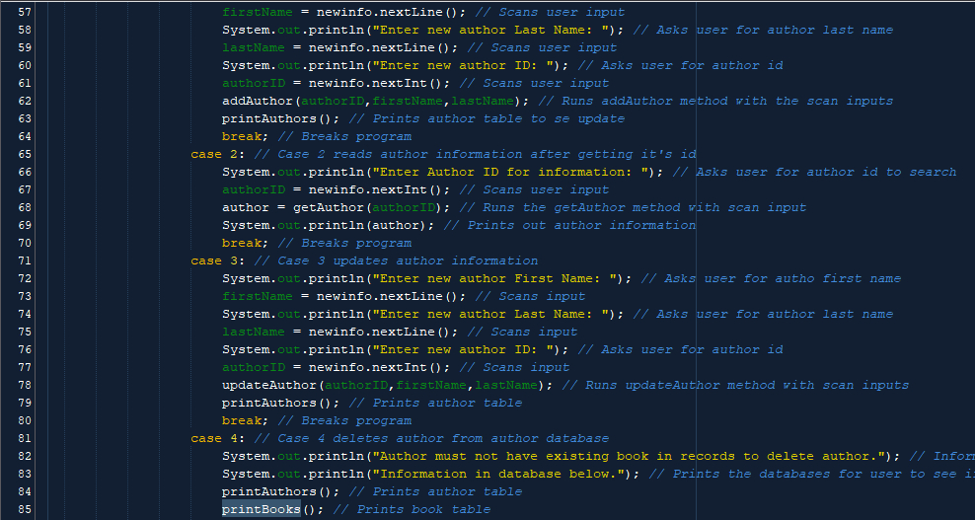

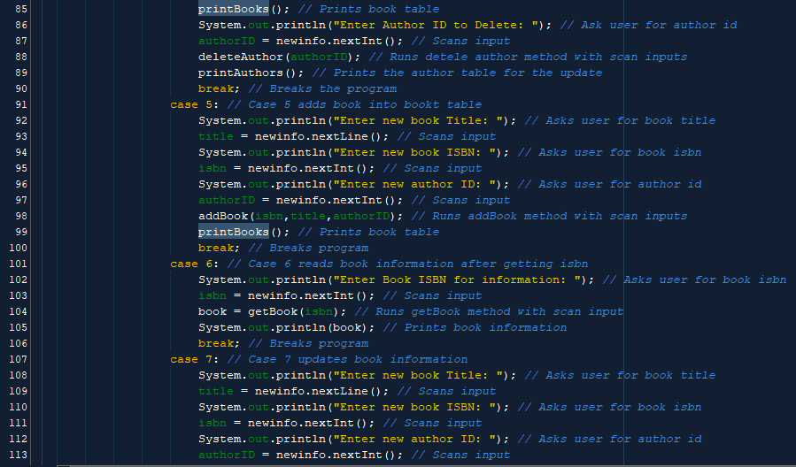

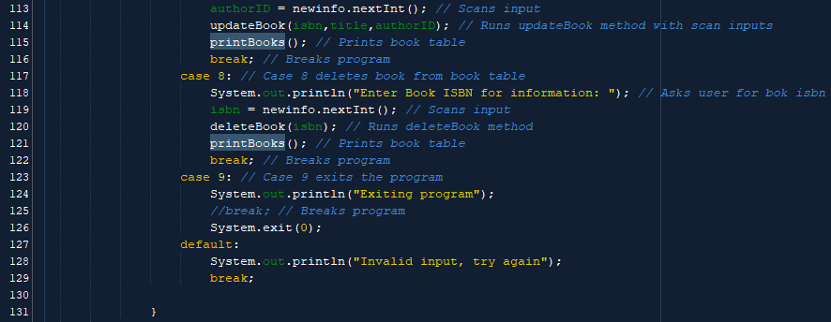

Created interface for CRUD for user input with all options to modify database.